Ex.no:5b | DATA VISUALIZATION USING MATPLOTLIB –  SALES DATA

AIM

To visualize and analyze the Fashion Products Analysis dataset using Line Chart, Bar Chart, and Pie Chart with Matplotlib to understand product trends, brand-wise comparisons, and category-wise product distribution.

ALGORITHM

Step 1: Import Pandas and Matplotlib libraries.

Step 2: Load the Fashion Products Analysis dataset into a DataFrame.

Step 3: Group the fashion products according to Brand and calculate the average price for each brand.

Step 4: Plot the brand-wise average price using a Line Chart to observe variations in product prices across brands.

Step 5: Group the dataset according to Category and calculate the number of products in each category.

Step 6: Plot the category-wise product count using a Bar Chart to compare products across different categories.

Step 7: Select the major product categories and calculate their product distribution proportions.

Step 8: Plot the category-wise product distribution using a Pie Chart.

Step 9: Add suitable titles, axis labels, legends, and display the visualizations.

CODE
import pandas as pd
import matplotlib.pyplot as plt
from google.colab import files

uploaded = files.upload()
csv_file = list(uploaded.keys())[0]

print("Uploaded File:", csv_file)

df = pd.read_csv(csv_file, encoding="latin1", low_memory=False)
print("\nDataset Loaded Successfully")

# 1. Line Chart – Average Price by Brand
brand_price = df.groupby("Brand")["Price"].mean()

plt.figure(figsize=(10,5))
plt.plot(brand_price.index, brand_price.values, marker="o")
plt.title("Average Product Price by Brand")
plt.xlabel("Brand")
plt.ylabel("Average Price")
plt.xticks(rotation=45)
plt.grid(True)
plt.tight_layout()
plt.show()

# 2. Bar Chart – Products by Category
category_count = df["Category"].value_counts().sort_values(ascending=False)

plt.figure(figsize=(12,6))
plt.bar(category_count.index, category_count.values)
plt.title("Number of Products by Category")
plt.xlabel("Category")
plt.ylabel("Number of Products")
plt.xticks(rotation=45, ha="right")
plt.tight_layout()
plt.show()

# 3. Pie Chart – Category Distribution
category_distribution = df["Category"].value_counts()
top_categories = category_distribution.head(6)

plt.figure(figsize=(8,8))
plt.pie(top_categories.values, labels=top_categories.index, autopct="%1.1f%%")
plt.title("Top 6 Categories by Product Distribution")
plt.show()

OUTPUT

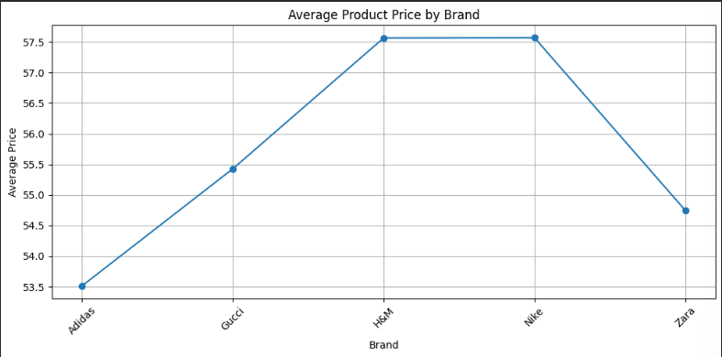
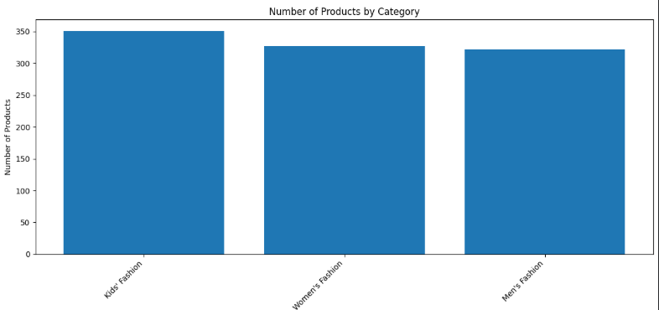
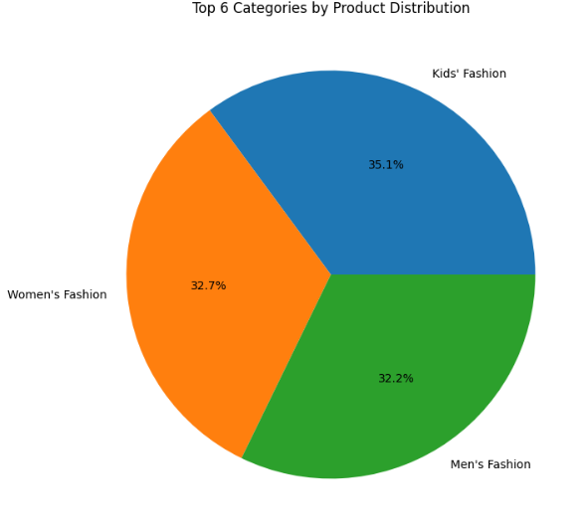

RESULT

